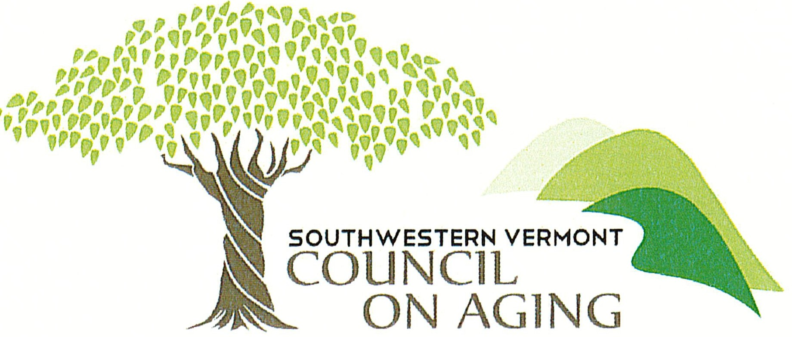

Evidence Based Wellness Grant Application

Southwestern Vermont Council on Aging (“SVCOA”) has a role to foster the development and implementation of a comprehensive and coordinated system to serve older Vermonters, age 60 and older, and family caregivers within our service area. We work with a variety of municipalities, businesses, nonprofit agencies, community partners and caregivers to help us in our mission is to support Southwestern Vermonters to age with dignity and choice in a home and community environment.

Grants awarded by SVCOA provide limited financial support to communities, organizations, partners, and caregivers to help SVCOA build greater capacity and to develop a network of support for older adults and family caregivers. Grants for evidence-based health promotion and disease prevention may be awarded to support community-based nonprofit service providers with which we collaborate or for-profit organizations who meet the qualifications of the grant. More information can be found on approved evidence based programs using the following links: https://acl.gov/programs/health-wellness/disease-prevention or https://www.ncoa.org/evidence-based-programs
SVCOA awards grants to organizations that are located in or directly serve older adults and family caregivers in our service area including Bennington and Rutland Counties.

The Older American Americans Act (“OAA”) delineates and regulates the scope of work of the area agencies on aging. The OAA requires that all services and supports be targeted to older adults with the greatest economic and social need, especially those who are:
- at risk of institutional placement
- low-income minority individuals
- limited English proficiency
- residing in rural areas

Please complete the attached application by September 26, 2022. For further information, contact the SVCOA Director of Nutrition and Community Services at CAnderson@svcoa.net Submit completed applications to CAnderson@svcoa.net by September 26, 2022.

.

Support of Older Vermonters Grant Application

Date of submission:

Contact Person:

Name of Organization:

Mission of Organization:

Address:

Nonprofit status : Yes No

Amount of grant funds requested:

Please submit your responses to the following questions in not more than two pages.

- Describe in detail the program or purpose for which this grant will be used. Include information as to how the funds will support older Vermonters with the greatest social and economic need in our service area.

- Describe how this program/project helps to build greater capacity in the network of services serving older Vermonters in their homes and communities.

- Describe your organization’s ability to implement this program/project.

- Describe your ability to provide data, quality results/outcomes, and financial details.

Please submit the following documents with this application:
- Line item expense budget for the program or project to be funded
- Appropriate IRS Form
- Audited income statement and balance sheet

FOR SVCOA USE ONLY:
Recommended for Finance Committee review: Yes___ No____
Board Approved: Yes___ No_____
Amount Approved: ____________

